1. CREATE DATABASE
MongoDB Query:
use Students
Explanation: Creates or switches to the Student database.
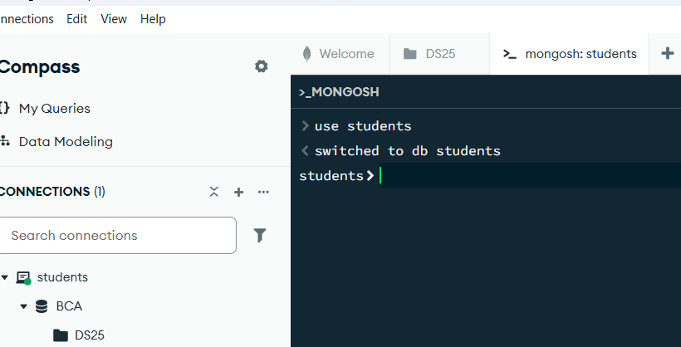

2. CREATE COLLECTION
MongoDB Query:
db. create Collection("students")
Explanation: Creates a collection named students.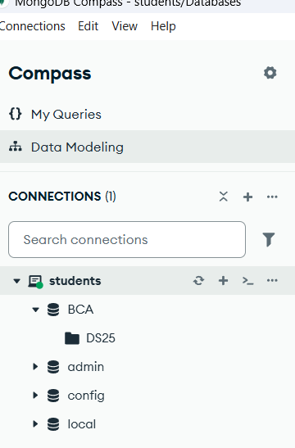

3. INSERT 50 STUDENTS
MongoDB Query:
db. students. Insert Many([ ])
{student_id:1,name:"Aarav Sharma",age:20,course:"BCA",city:"Lucknow"},
{student_id:2,name:"Priya Singh",age:19,course:"BCA",city:"Kanpur"},
{student_id:3,name:"Rahul Verma",age:21,course:"BCA",city:"Ayodhya"},
{student_id:4,name:"Ananya Gupta",age:20,course:"BBA",city:"Lucknow"},
{student_id:5,name:"Aditya Mishra",age:22,course:"BCA",city:"Prayagraj"},
{student_id:6,name:"Neha Yadav",age:19,course:"BSc",city:"Gorakhpur"},
{student_id:7,name:"Rohan Kumar",age:20,course:"BCA",city:"Varanasi"},
{student_id:8,name:"Sneha Singh",age:21,course:"BBA",city:"Lucknow"},
{student_id:9,name:"Vivek Pandey",age:22,course:"BCA",city:"Bareilly"},
{student_id:10,name:"Pooja Verma",age:20,course:"BSc",city:"Agra"},
{student_id:11,name:"Arjun Tiwari",age:21,course:"BCA",city:"Lucknow"},
{student_id:12,name:"Kajal Sharma",age:19,course:"BCA",city:"Sitapur"},
{student_id:13,name:"Aman Singh",age:22,course:"BBA",city:"Kanpur"},
{student_id:14,name:"Riya Gupta",age:20,course:"BCA",city:"Ayodhya"},
{student_id:15,name:"Karan Yadav",age:21,course:"BSc",city:"Lucknow"},
{student_id:16,name:"Simran Khan",age:20,course:"BCA",city:"Barabanki"},
{student_id:17,name:"Mohit Verma",age:22,course:"BCA",city:"Unnao"},
{student_id:18,name:"Nisha Patel",age:19,course:"BBA",city:"Lucknow"},
{student_id:19,name:"Rohit Mishra",age:21,course:"BCA",city:"Prayagraj"},
{student_id:20,name:"Isha Singh",age:20,course:"BSc",city:"Varanasi"},
{student_id:21,name:"Saurabh Gupta",age:22,course:"BCA",city:"Lucknow"},
{student_id:22,name:"Muskan Yadav",age:19,course:"BCA",city:"Gonda"},
{student_id:23,name:"Deepak Kumar",age:21,course:"BBA",city:"Kanpur"},
{student_id:24,name:"Shreya Sharma",age:20,course:"BCA",city:"Lucknow"},
{student_id:25,name:"Nitin Pandey",age:22,course:"BSc",city:"Gorakhpur"},
{student_id:26,name:"Komal Verma",age:19,course:"BCA",city:"Ayodhya"},
{student_id:27,name:"Abhishek Singh",age:21,course:"BCA",city:"Lucknow"},
{student_id:28,name:"Tanya Gupta",age:20,course:"BBA",city:"Agra"},
{student_id:29,name:"Vishal Yadav",age:22,course:"BCA",city:"Bareilly"},
{student_id:30,name:"Payal Mishra",age:19,course:"BSc",city:"Lucknow"},
{student_id:31,name:"Harsh Tiwari",age:21,course:"BCA",city:"Sitapur"},
{student_id:32,name:"Sakshi Singh",age:20,course:"BCA",city:"Kanpur"},
{student_id:33,name:"Yash Verma",age:22,course:"BBA",city:"Lucknow"},
{student_id:34,name:"Ritika Sharma",age:19,course:"BCA",city:"Gonda"},
{student_id:35,name:"Manish Gupta",age:21,course:"BSc",city:"Unnao"},
{student_id:36,name:"Ayesha Khan",age:20,course:"BCA",city:"Lucknow"},
{student_id:37,name:"Varun Singh",age:22,course:"BCA",city:"Varanasi"},
{student_id:38,name:"Divya Yadav",age:19,course:"BBA",city:"Barabanki"},
{student_id:39,name:"Shubham Kumar",age:21,course:"BCA",city:"Prayagraj"},
{student_id:40,name:"Megha Gupta",age:20,course:"BSc",city:"Lucknow"}
])

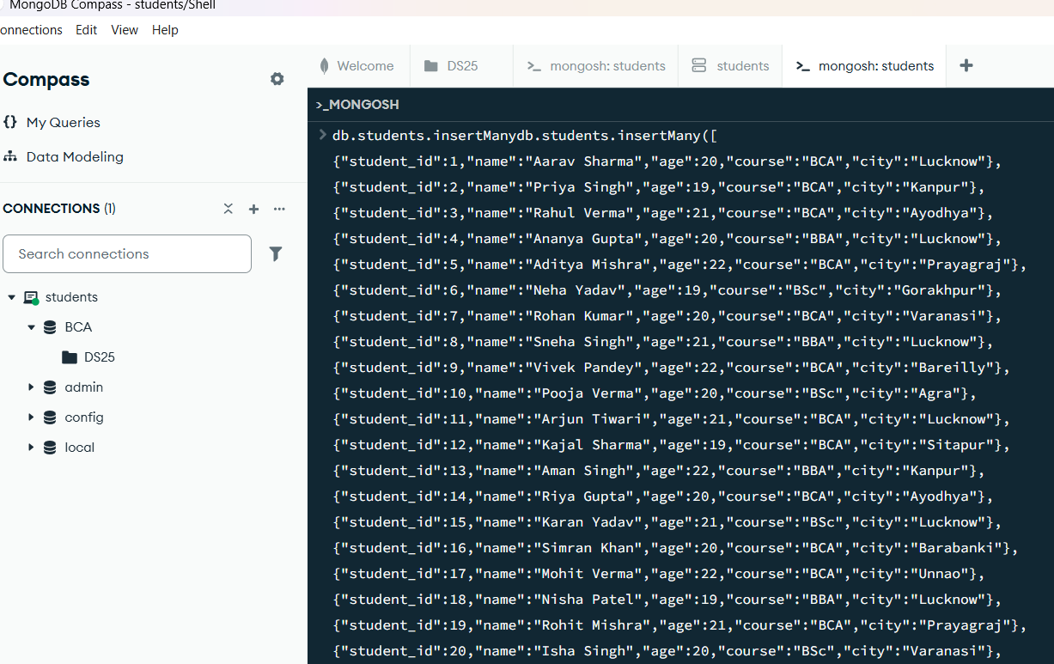
Explanation: Inserts multiple student documents into the collection.

4. DISPLAY ALL STUDENTS
MongoDB Query:
db. students. Find ()
Explanation: Retrieves documents from the students collection.
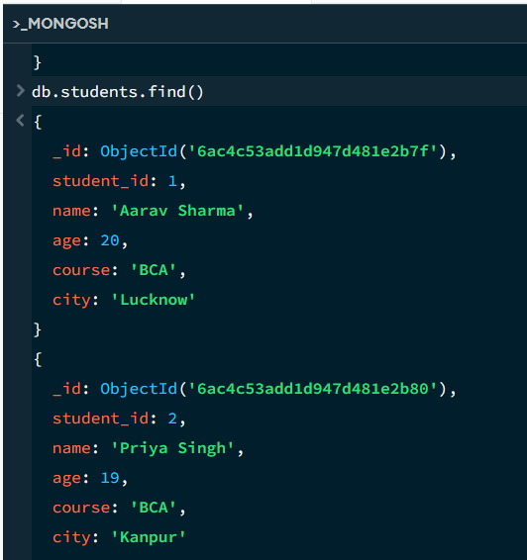

5. EQUAL TO — $eq
MongoDB Query:
db. students. Find ({age: {$eq: 20}})
Explanation: Finds students whose age are exactly 20
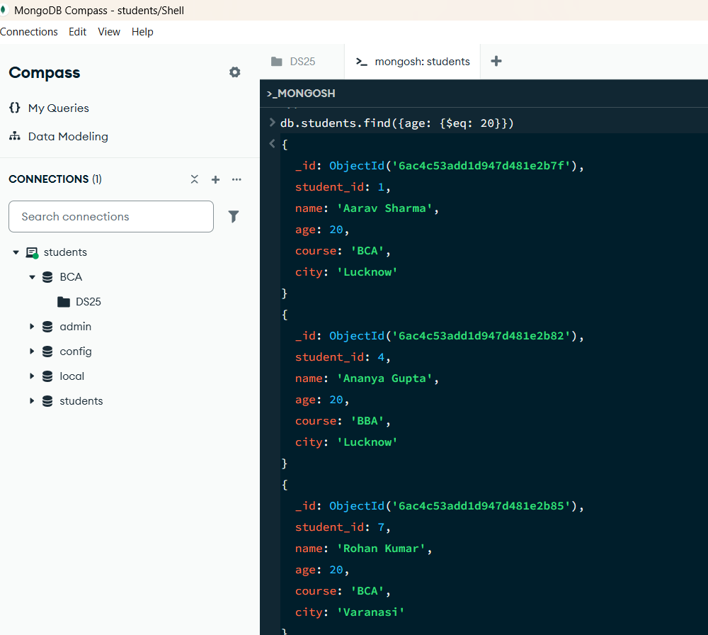

6. GREATER THAN — $gt
MongoDB Query:
db.students.find({age: {$gt: 18}})
Explanation: Finds students whose age are greater than 18
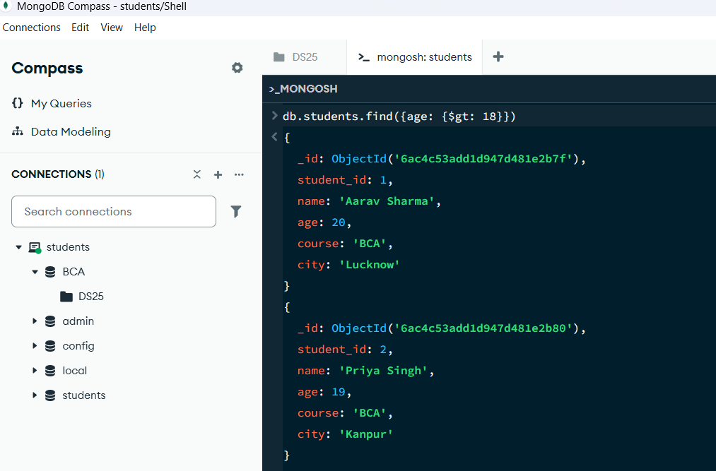

7. LESS THAN — $lt
MongoDB Query:
db. students. find ({age: {$lt: 23}})
Explanation: Finds students whose age are less than 23.

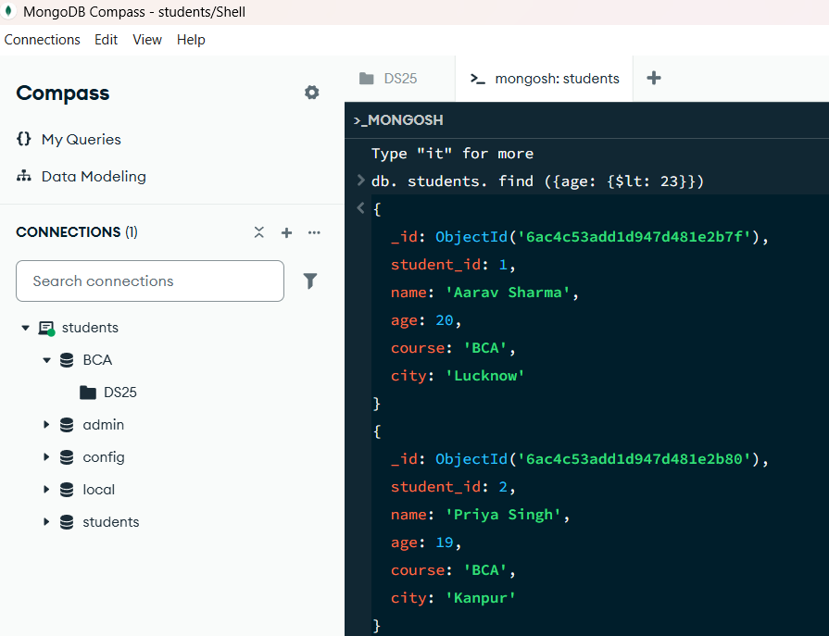

8. GREATER THAN OR EQUAL TO — $gte
MongoDB Query:
db. students. find({age: {$gte: 20}})
Explanation: Finds students whose age are 20 or above.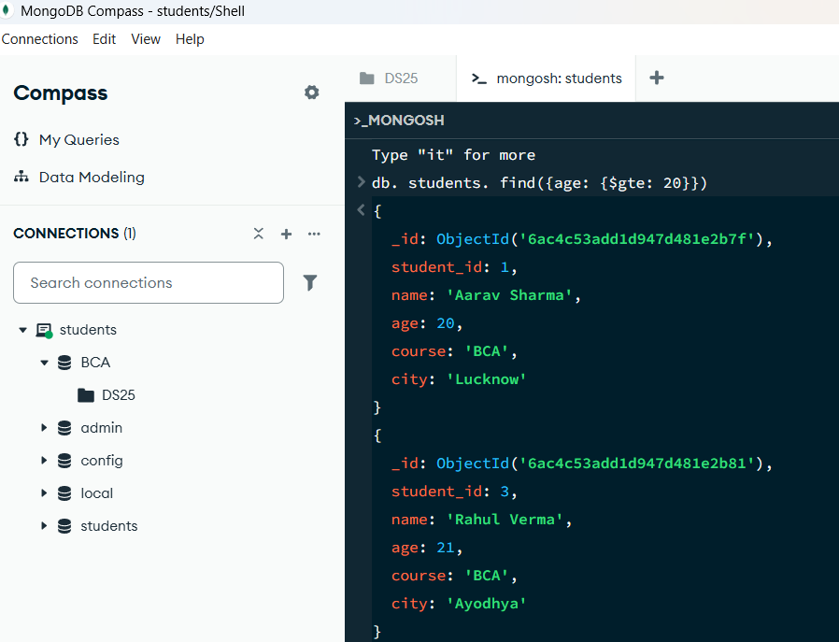

9. LESS THAN OR EQUAL TO — $lte
MongoDB Query:
db. students. find({age: {$lte: 20}})
Explanation: Finds students whose age are 20 or below.
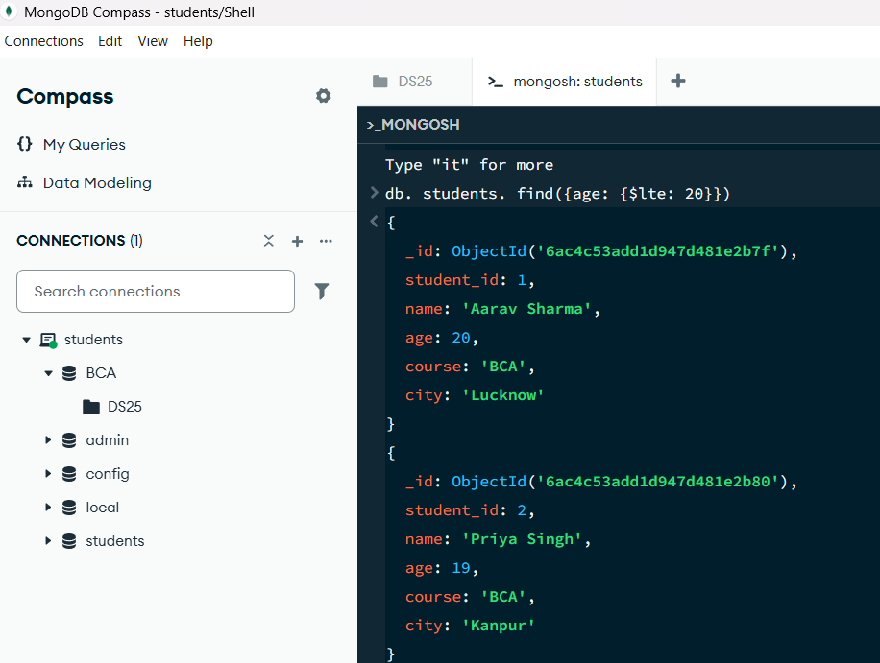

10. UPDATE OPERATION
MongoDB Query:
db.students.updateOne(
{student_id:1},
{$set:{age:20}}
)
Explanation: Updates the age to 20 of the student with student_id:1.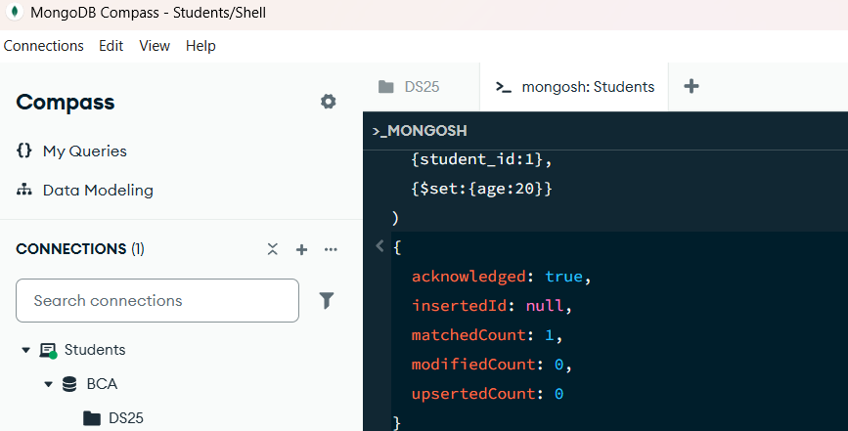

11. DELETE ONE OPERATION
MongoDB Query:
db.students.deleteOne({student_id:10})
Explanation: Deletes one document matching student_id:10.
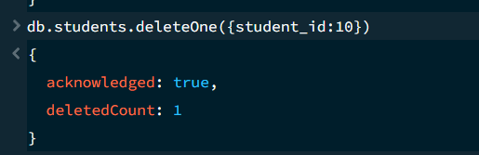

12. DELETE MANY OPERATION
MongoDB Query:
db.students.deleteMany({
age: {$lt:20}
})
Explanation: Deletes all students having age below 20
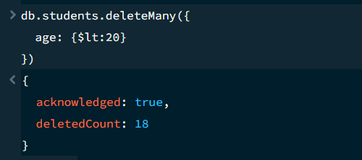

13. AND OPERATION — $and
MongoDB Query:
db. students. find({
$and:[
{age:{$gt:20}},
]
})
Explanation: Finds students satisfying both conditions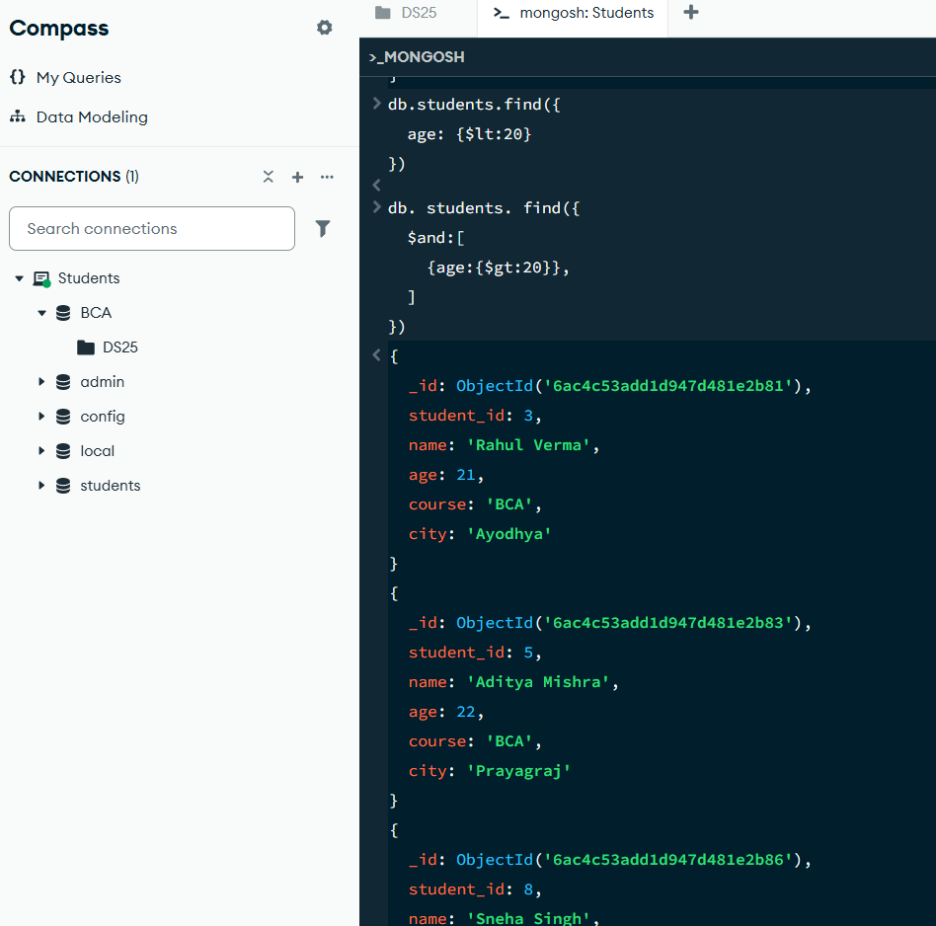

14. OR OPERATION — $or
MongoDB Query:
db.students.find({
$or:[
{city:"Lucknow"},
{Surname:”verma "}
]
})
Explanation: Finds students from Lucknow or Verma.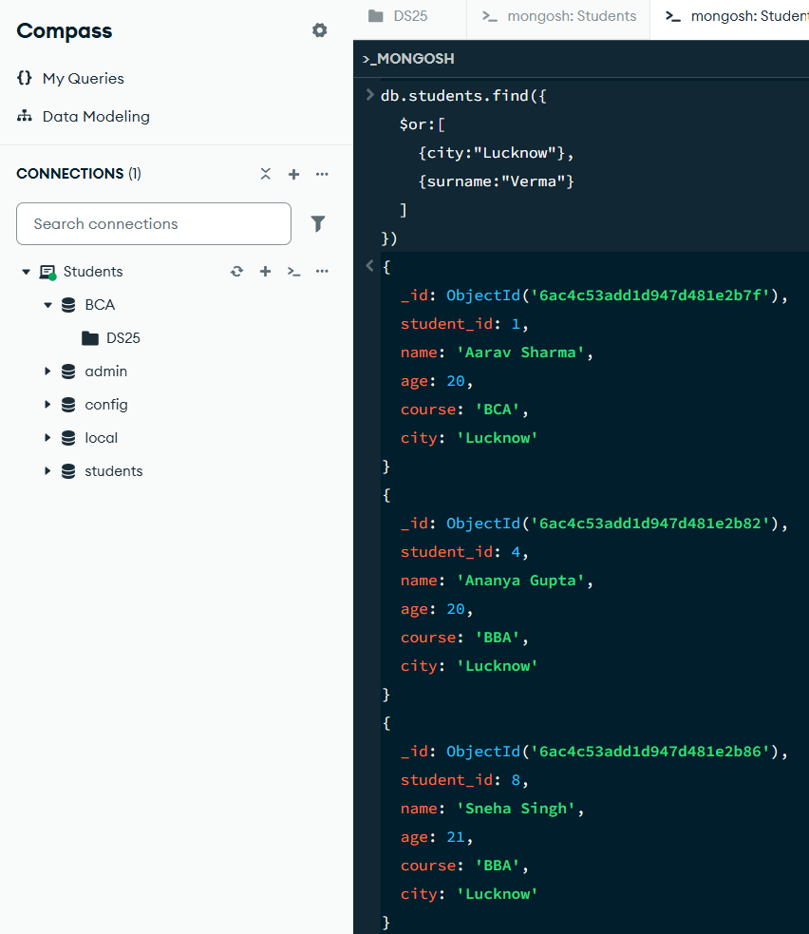

15. SORT OPERATION
A.MongoDB Query:
db. students. find (). sort({age : 1})
Explanation: Sorts students by age from lowest to highest. Use 1 for ascending order.
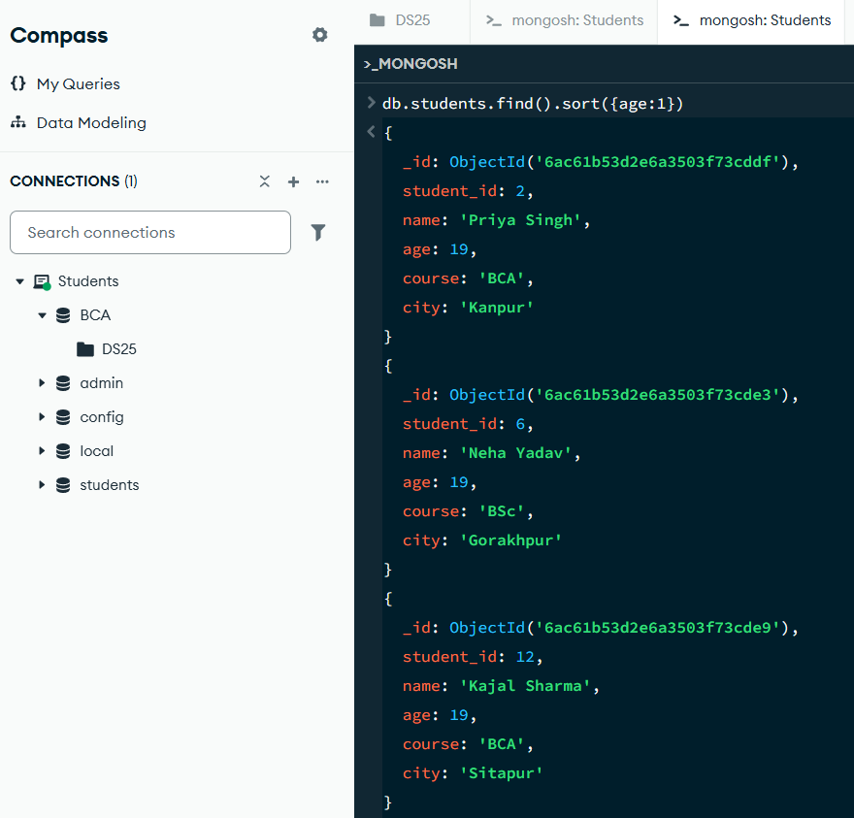

B. MongoDB Query:
db. students. find (). Sort ({age: -1})
Explanation: Sorts students by age from highest to lowest. Use -1 for descending order.
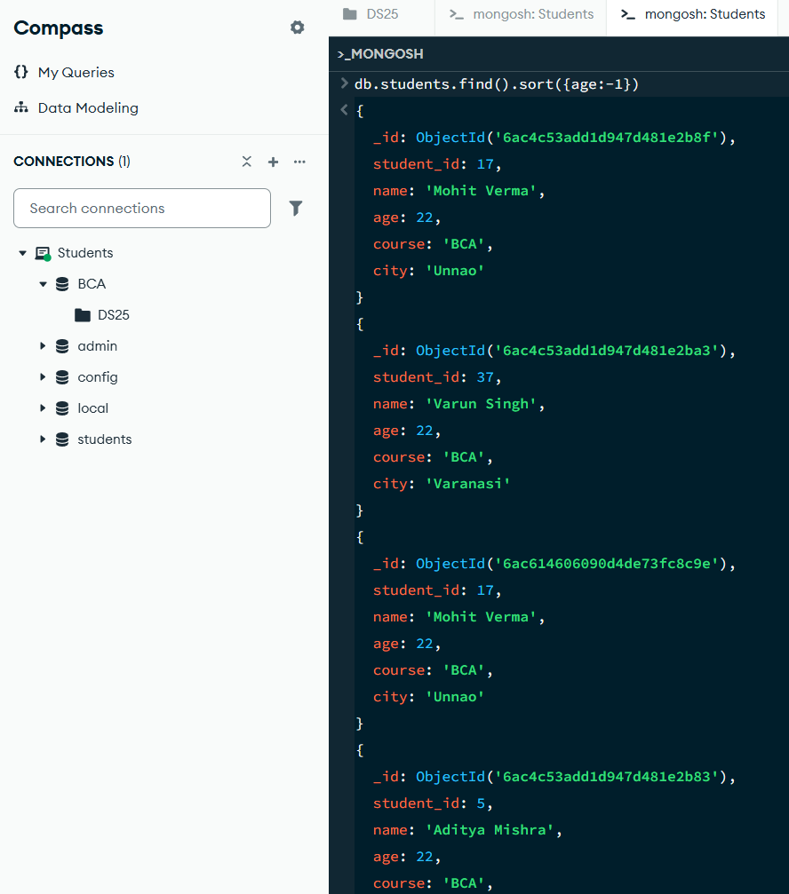
16. LIMIT OPERATION
MongoDB Query:
db. students. find (). limit (5)
Explanation: Displays only the first five documents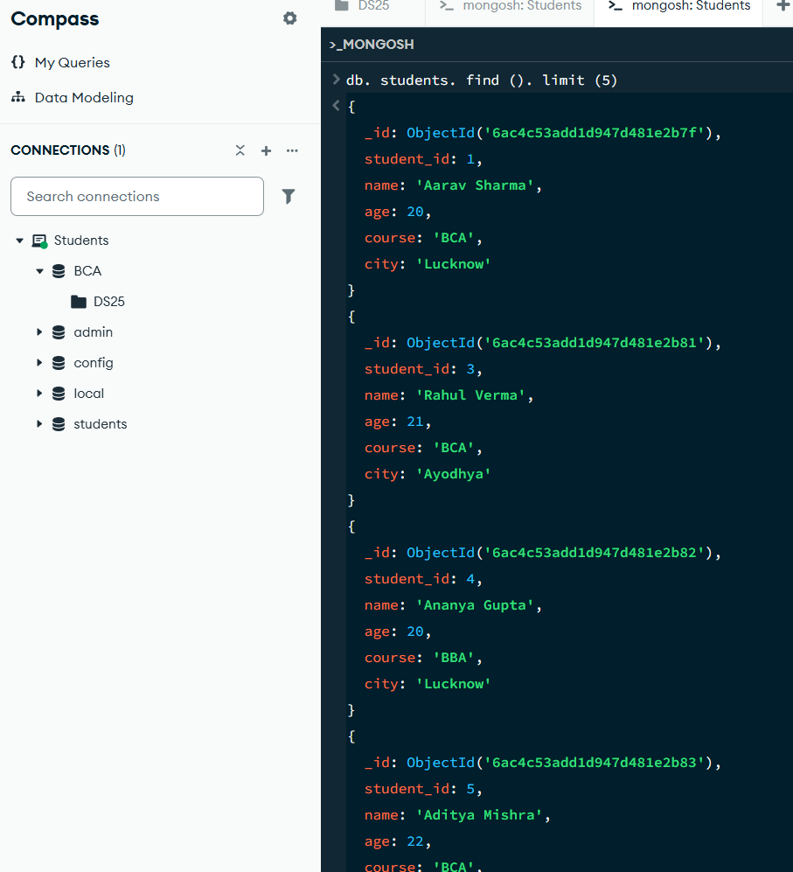

17. SEARCH BY CITY
MongoDB Query:
db.students.find({city:"Lucknow"})
Explanation: Finds all students whose city is Lucknow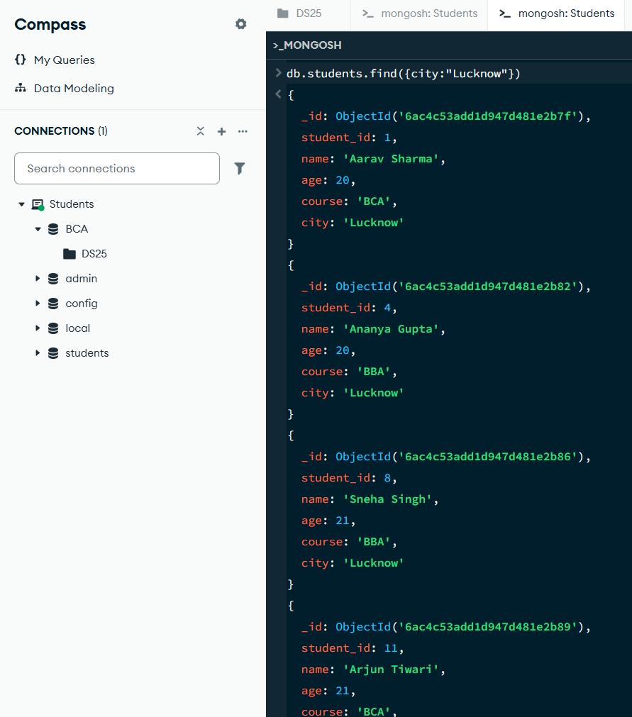

18. COUNT DOCUMENTS
MongoDB Query:
db. students. count Documents ()
Explanation: Counts documents currently present in the collection (performing after the delete function).
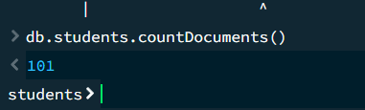

Operator | Meaning | Example
$eq | Equal to | marks: {$eq:88}
$gt | Greater than | marks: {$gt:85}
$lt | Less than | marks: {$lt:60}
$gte | Greater than or equal to | marks: {$gte:90}
$lte | Less than or equal to | marks: {$lte:70}
$and | All conditions true | $and:[...]
$or | At least one condition true | $or:[...]

MONGODB OPERATORS USED:

